**Ticket Rule:**

**Process -> Ticket (Label)**

**Purpose: With in a Transaction/Flow we can jump from one step/Assignment  to other step.**

* **Ticket Option available under assignment shape properties. For One Assignment we can add multiple Tickets.**
* **Ticket Rule we have to call under to Page.**
* **To set the ticket we can use predefined activity : SetTicket ( From UI Design )**
* **Shape: Change Stage: Used to jump from one flow to other flow**

**Req: Customize flow to use ticket Rule:**

**- Jump from Auto Vehicle Assignment to Address Assign If vehicle is Brand new Vehicle**

**- Add a Check Box property : BrandNewVehicle**

**- Add this Property in Personal Vehicle Section**

**- If Check box is selected jump to Address Assignment & If Check box is not selected it will execute LOSS & Approval assignment**

**-After Jump Update WO Status to/ Case Status "Auto-Approved" ( UpdateStatus)**

**Add Property:**

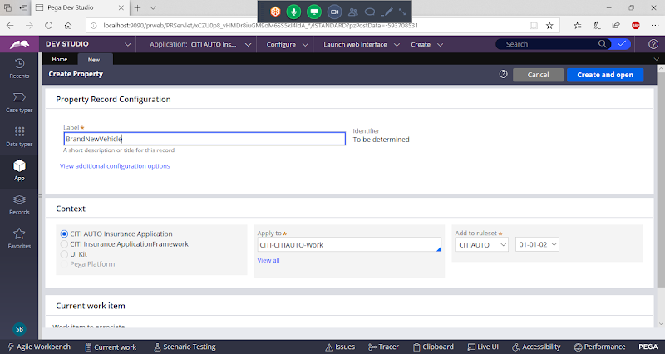

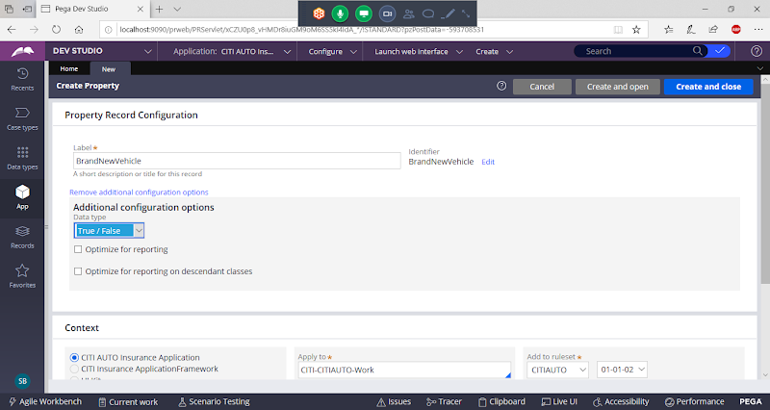

**Create & Close**

**Open Personal Vehicle section & Add Property**

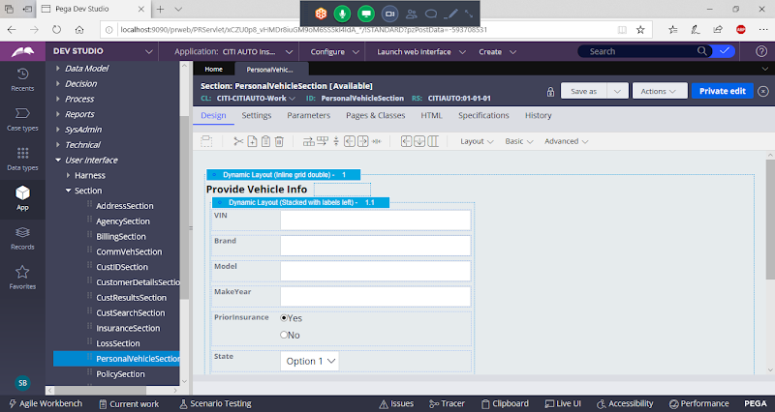

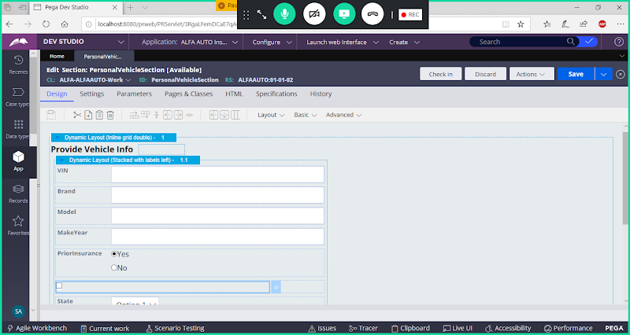

**Add Caption for Checkbox**

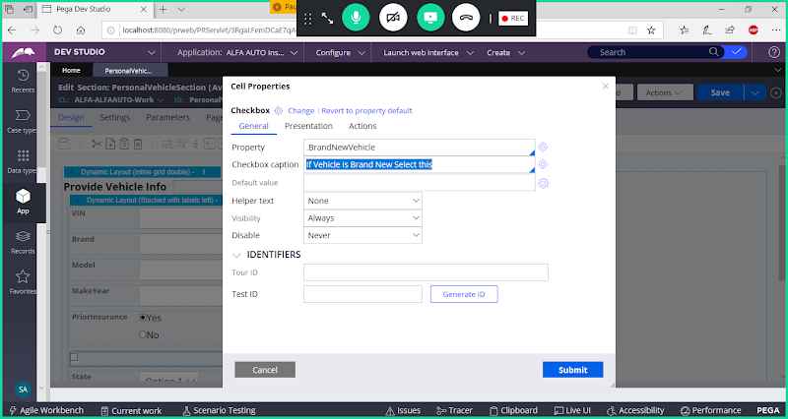

**Submit**

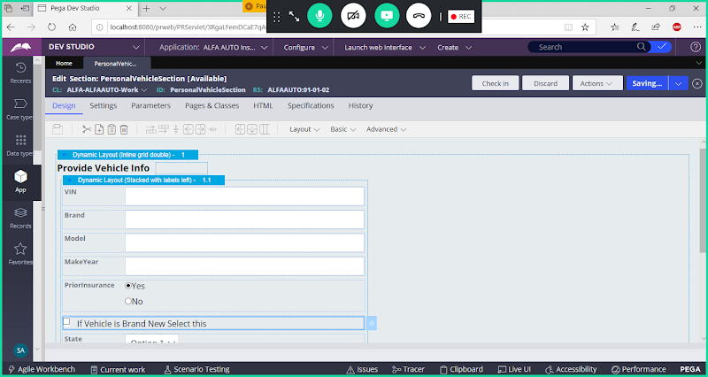

**Save & Check in**

**Add Ticket Rule:**

**Add from Process Category**

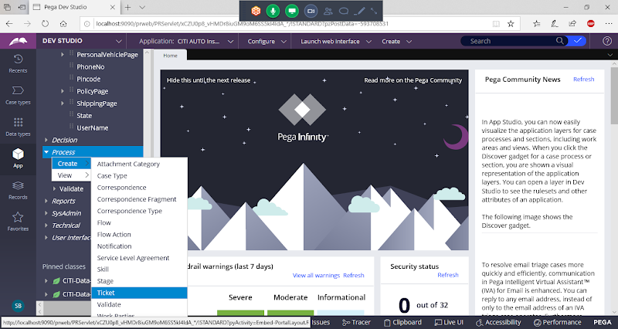

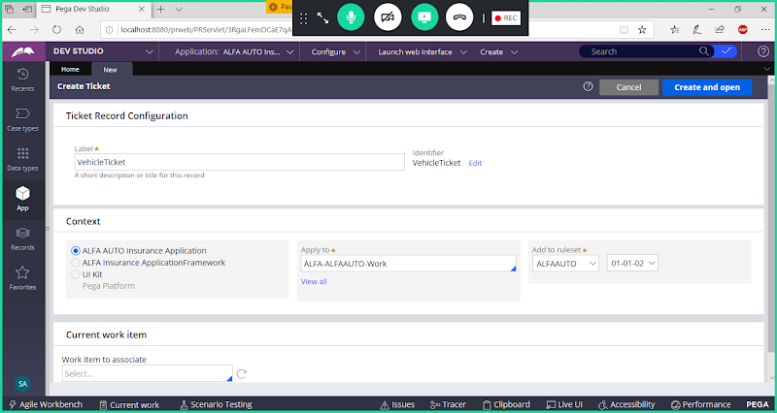

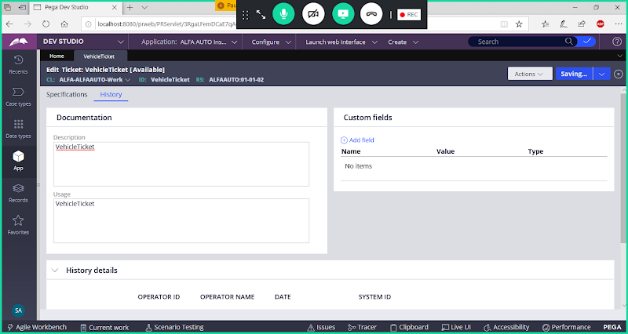

**Save**

**Now we have to map ticket rule in Address assignment( i.e to which shape you are jumping inside that map the rule)**

**Open Insurance Flow & Add Ticket rule under Address Assignment:**

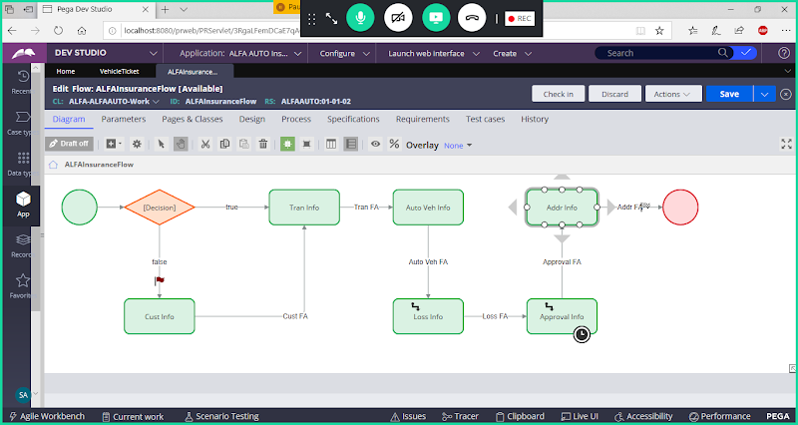

**Double Click on Address Assignment**

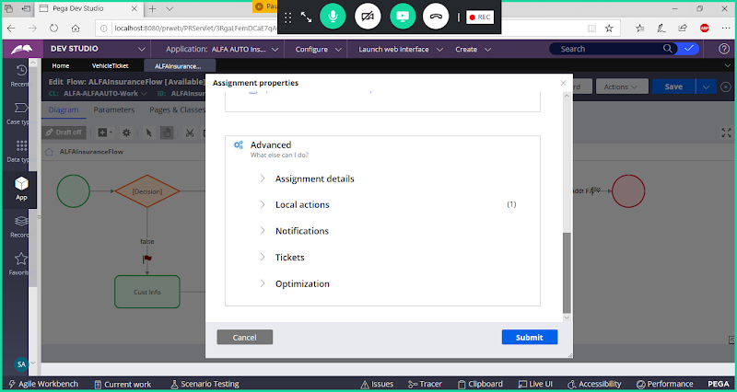

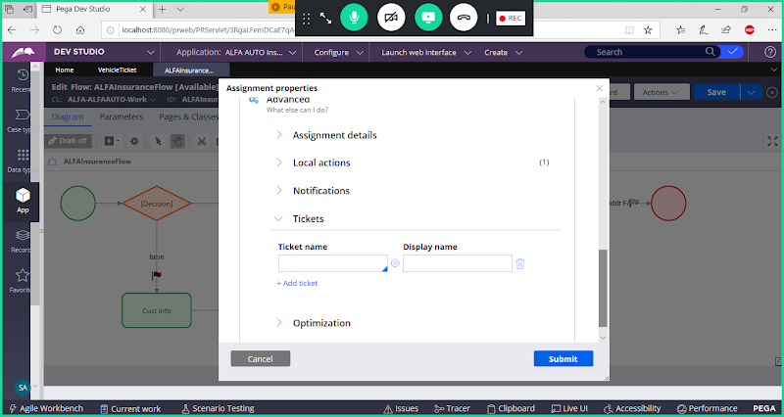

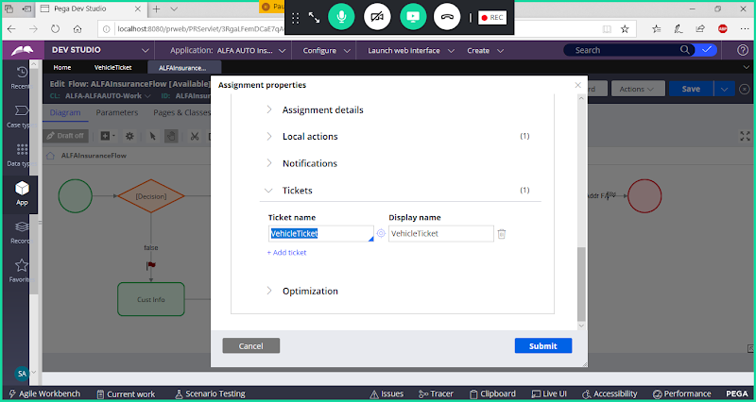

**Submit & Save Flow**

**Create Activity to Set the Ticket & Update Status:**

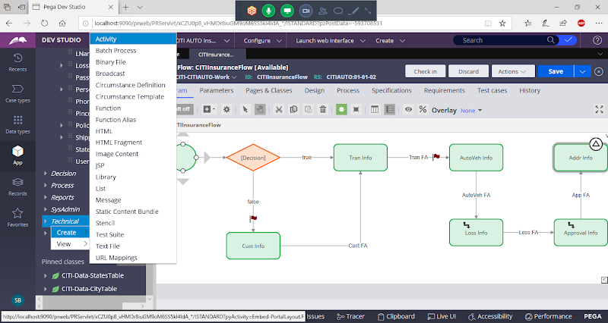

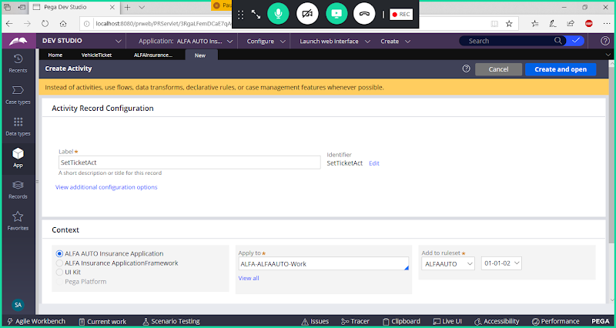

**Open**

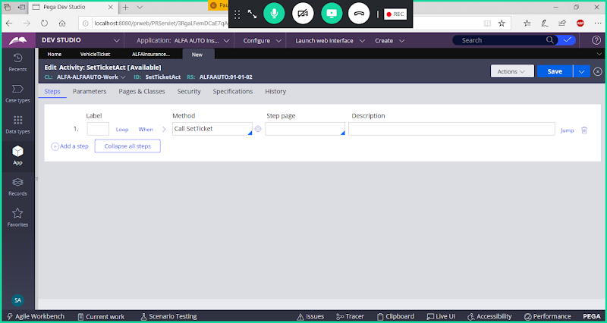

**Fill Parameters**

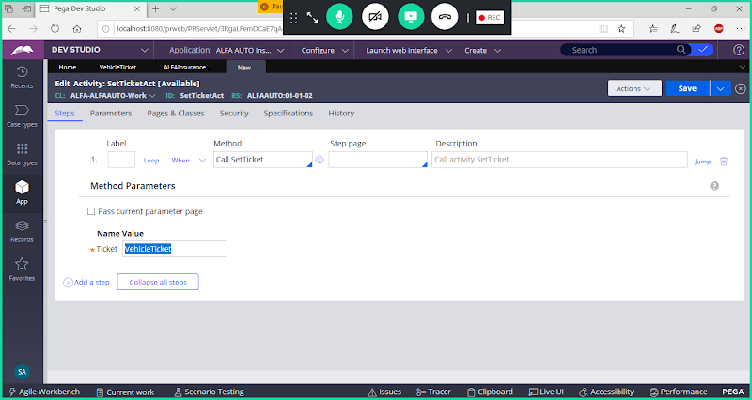

**Add Precondition using Expression Builder: ( the Purpose is If Check Box Selected then only read Activity else exit Activity)**

**Click on When**

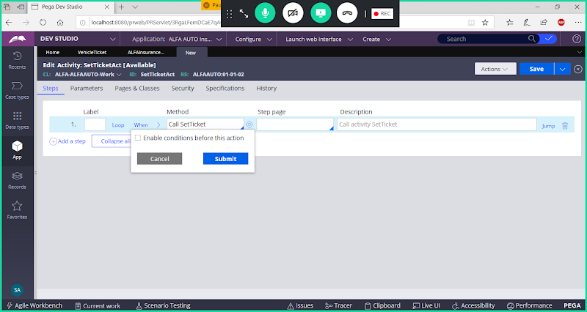

**Enable Condition**

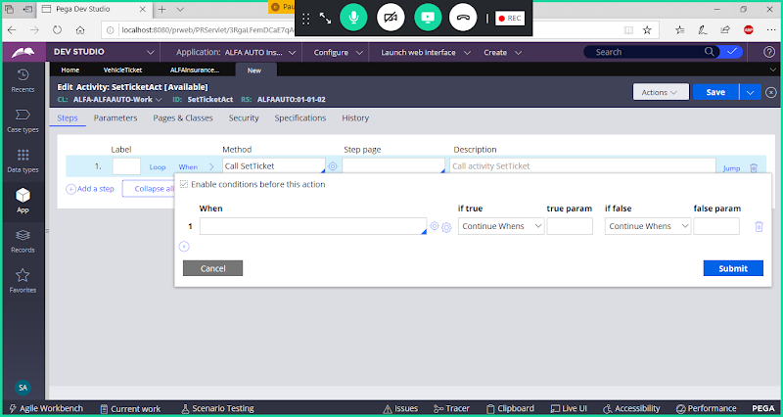

**Now Open Expression builder**

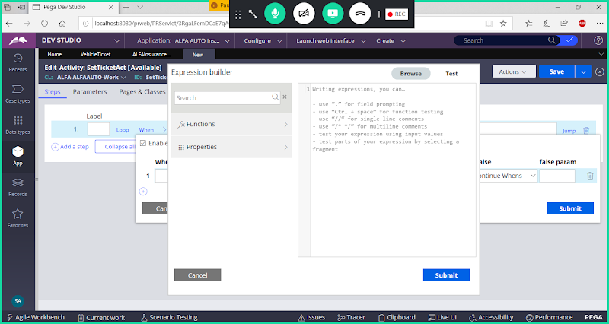

**Use Function: equalsignorecase**

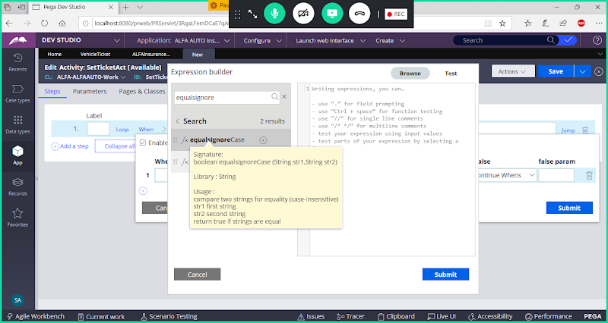

**select & Add**

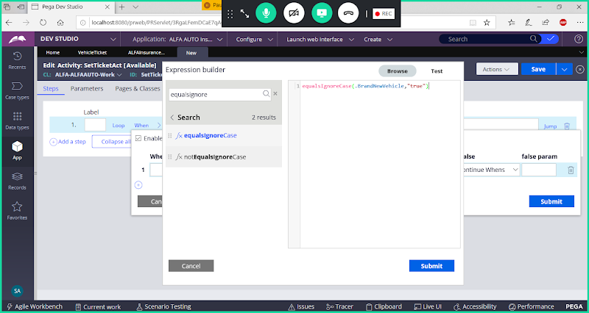

**Submit**

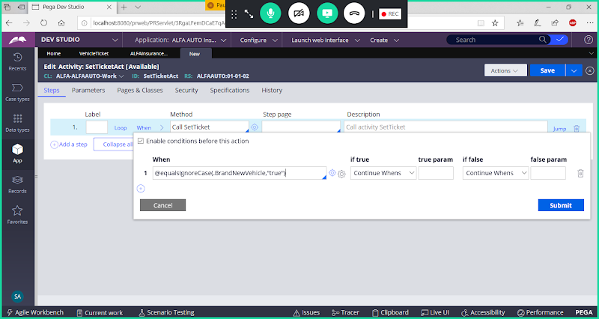

**True- Continue When**

**False - Exit Activity**

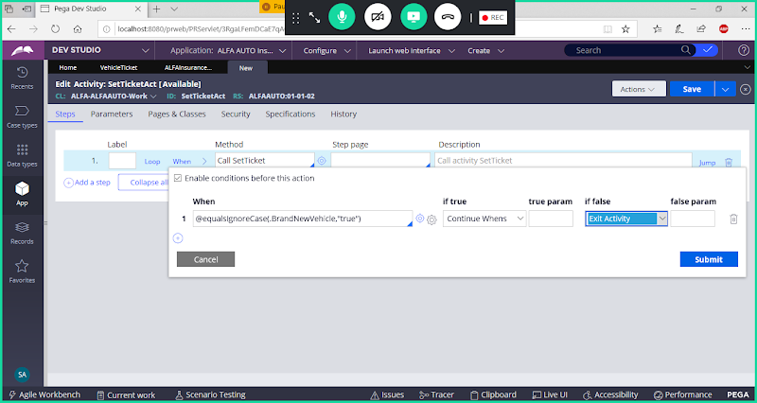

**Click on Submit**

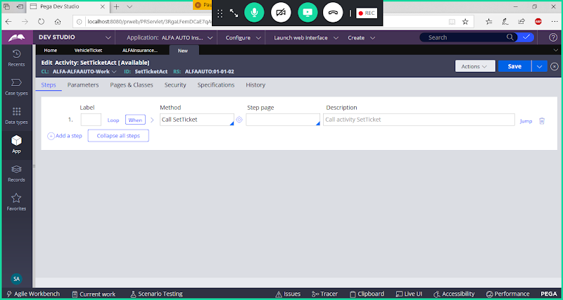

**Add Step2**

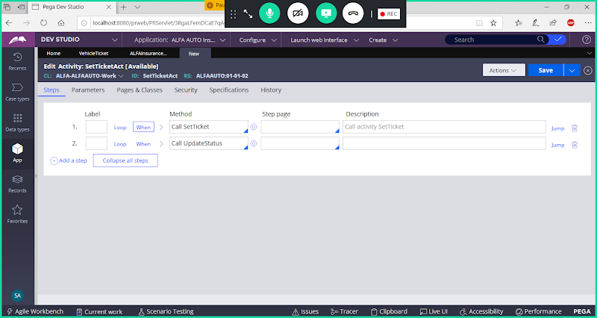

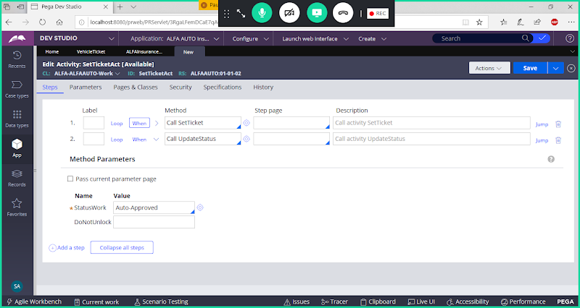

**Save Activity**

**Call This Activity in AUTO Vehicle Flowaction under Post Processing**

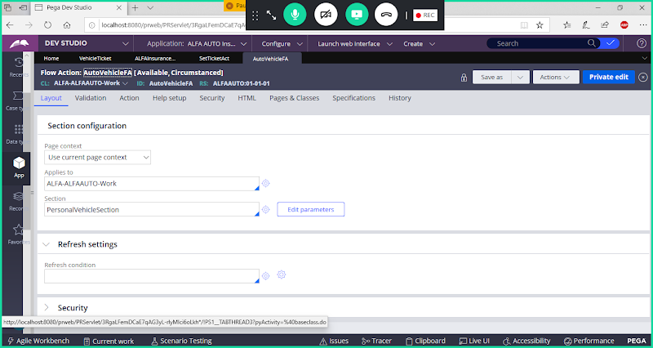

**Go to Action Tab**

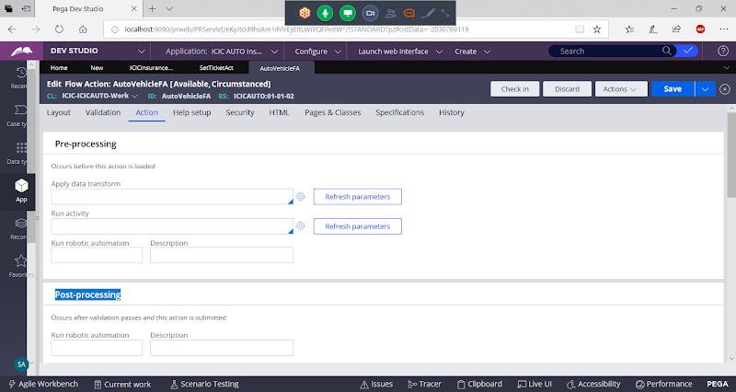

**Call Activity**

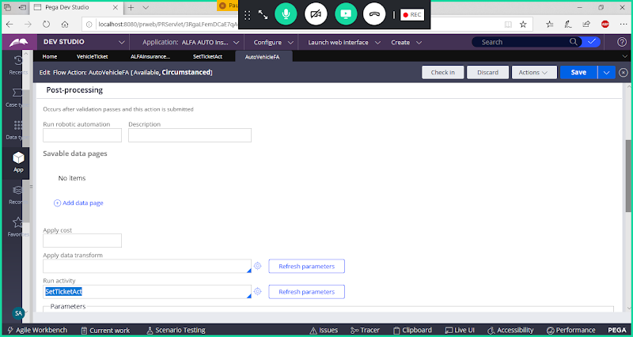

**Save Flowaction & Check in**

**Now Run Flow**

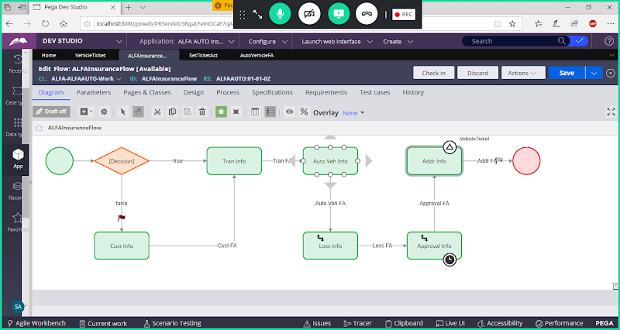

**Select Check Box, It will jump to Address Assignment**

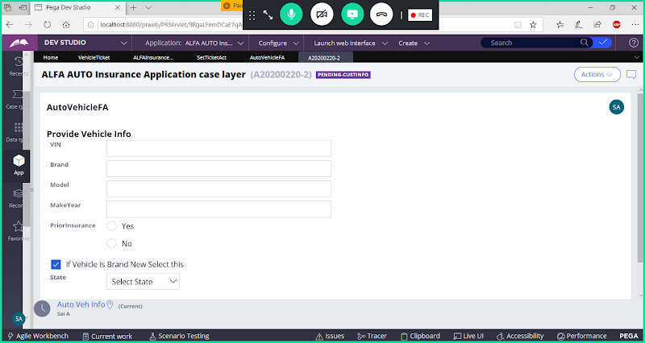

**Submit**

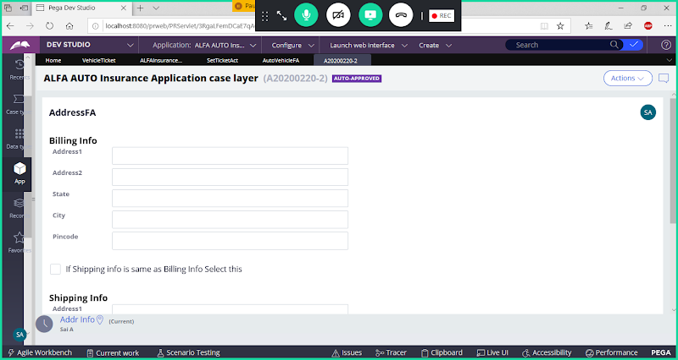

**-----**

**If Check box Not selected - > It will Execute LOSS & Approval & then Address Assignment**